Writing the system call code in a file and creating a Makefile for the system call:

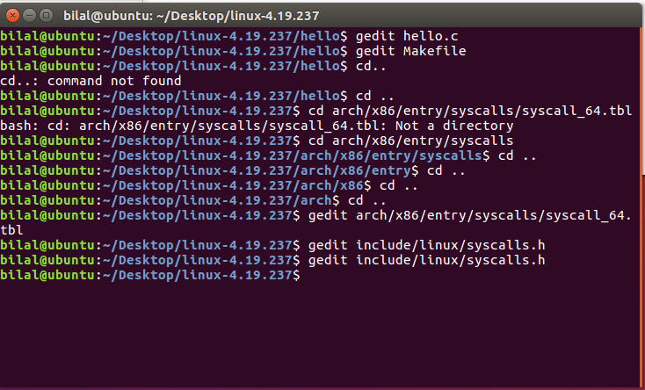

1. **Adding my Roll number in place of the kernel version**

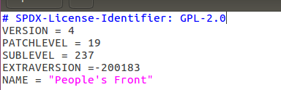

1. **Adding hello folder in the kernel’s MakeFile**



1. **Confirming the presence of the config file using ls**

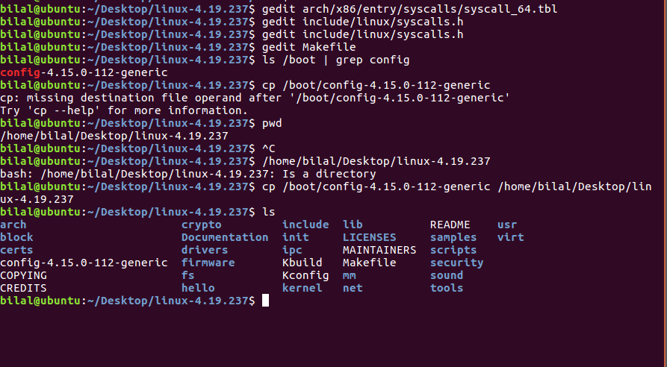

1. **Checking the number of cores available using lscpu**

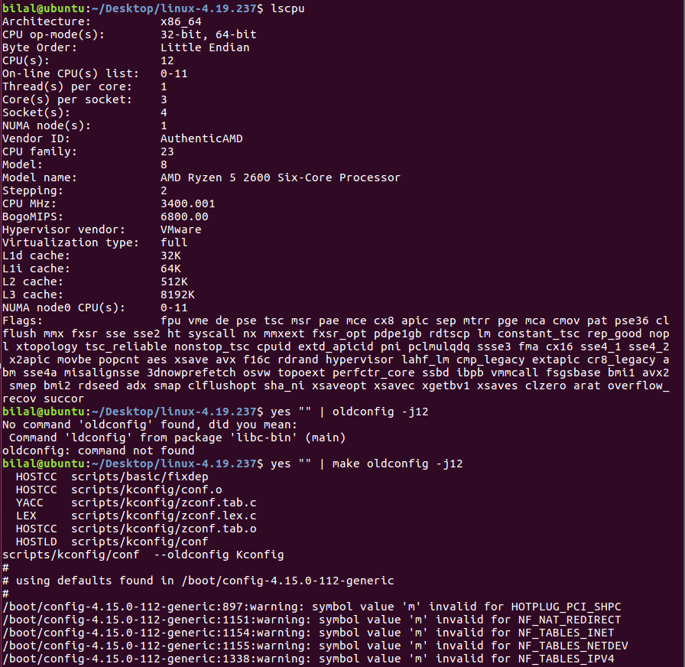

1. **Cleaning the kernel**

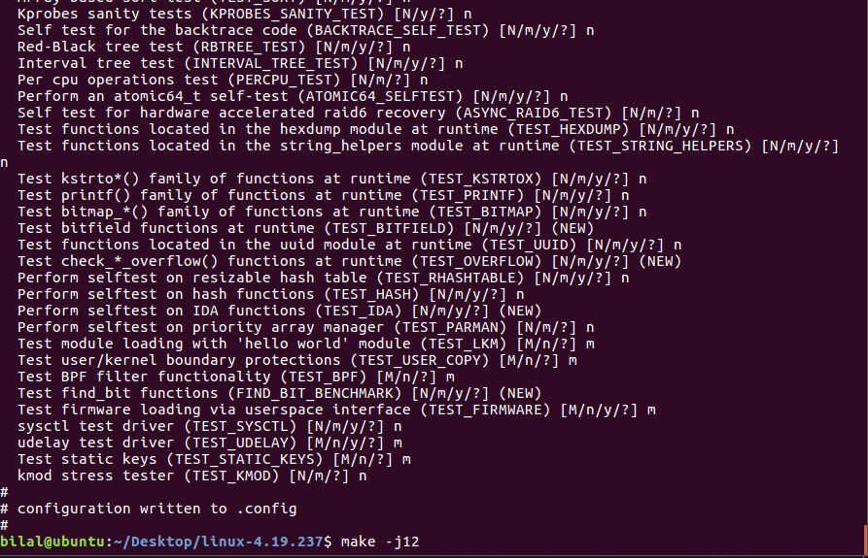

1. **Compiling the kernel**

After the wait of 21 mins and 15 secs….

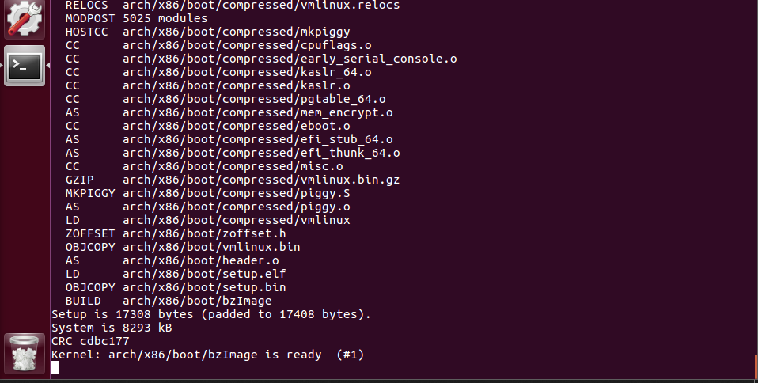

And 5 more mins…

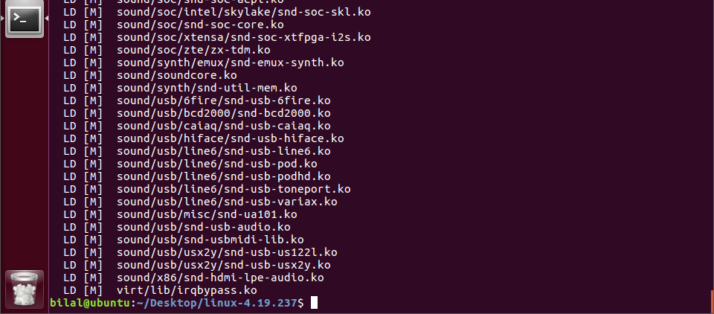

1. **Installing the modules**

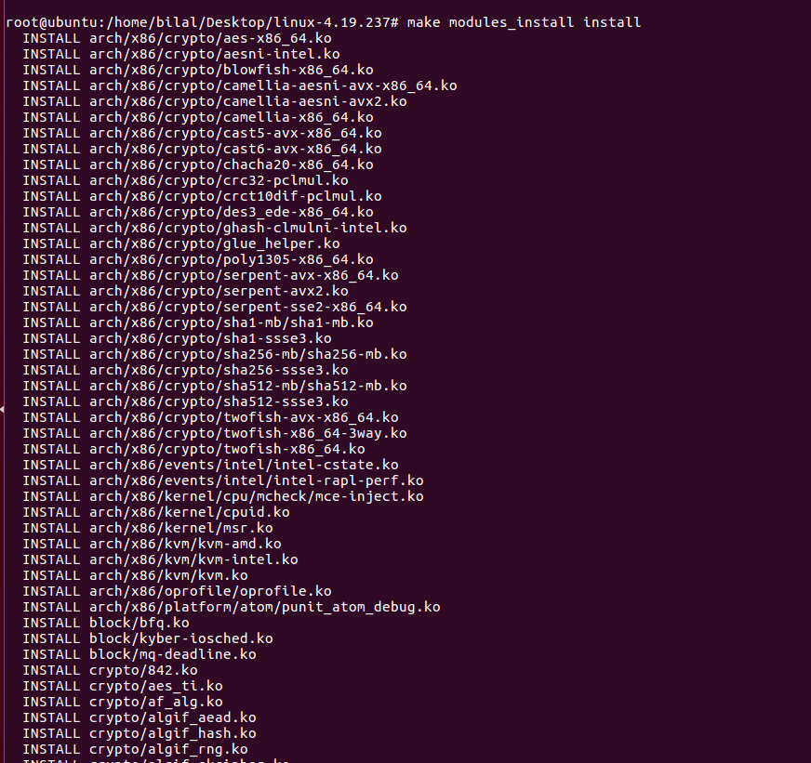

1. **Kernel compilation done (Finally….)**

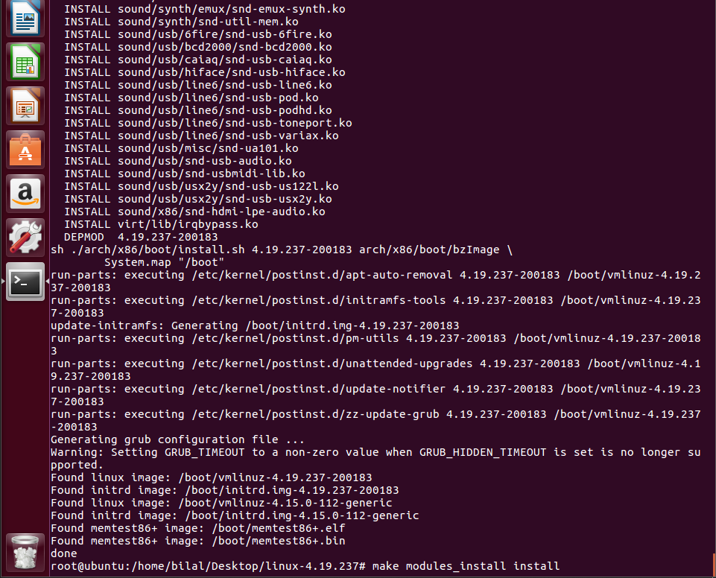

1. **Booting from the compiled kernel (Opening the Advanced options)**

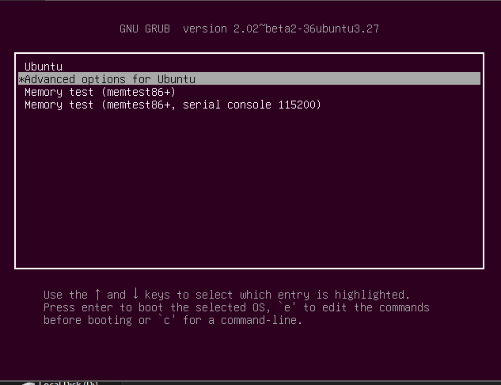

1. **Selecting the kernel with my Roll No.**

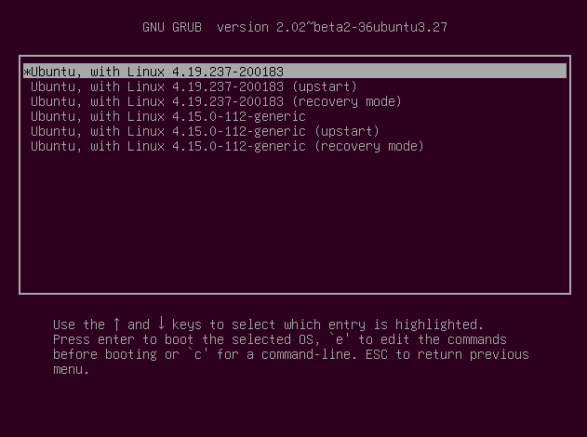

1. **Logged In!**

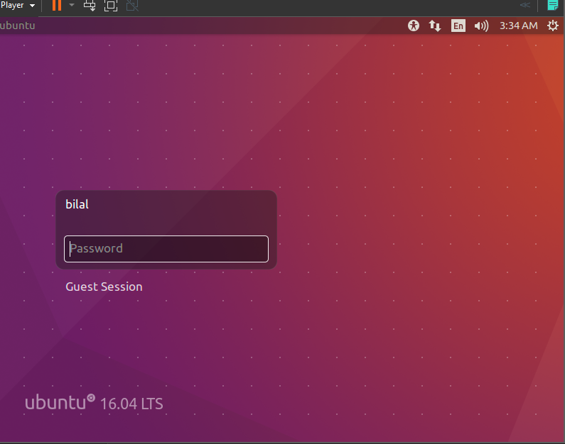

1. **Loading**

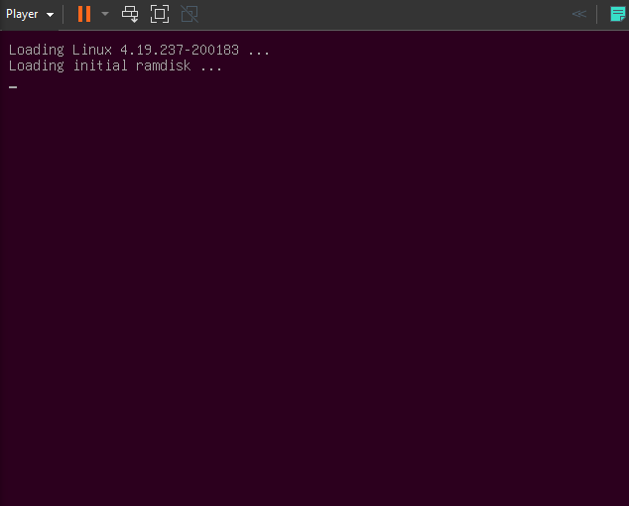

1. **Checking kernel version with my own Roll No.**

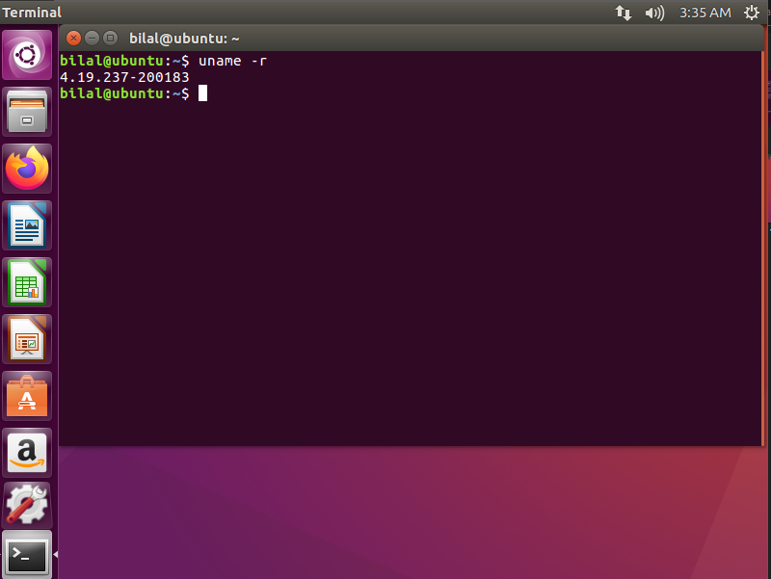

1. **Code to test System Call**

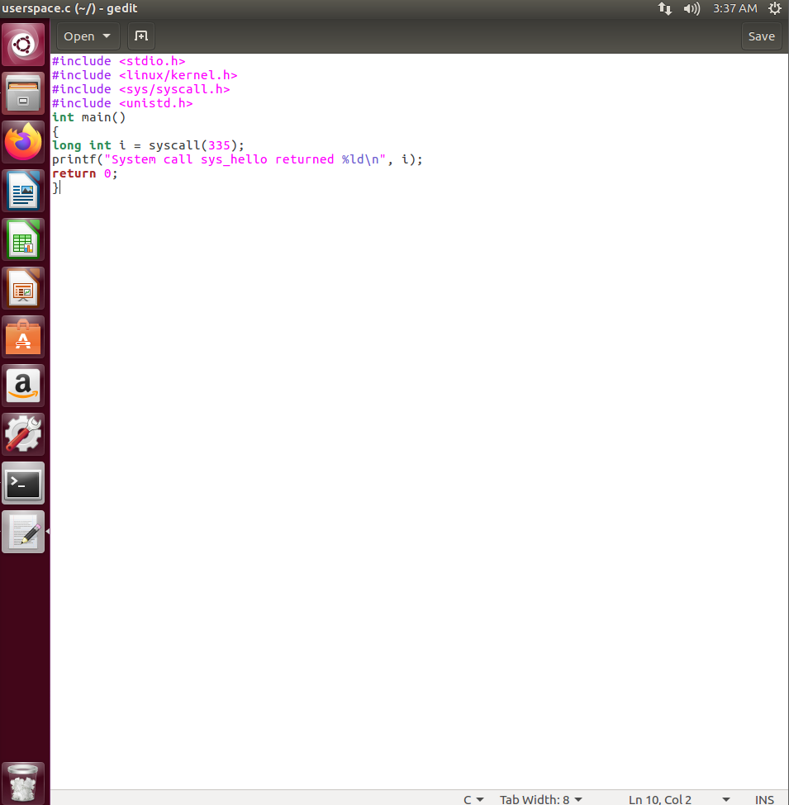

1. **System Call implemented Successfully**

